# **Work Breakdown Agreement – Assignment 2**

|  |  |
| --- | --- |
| Item | Person in charge |
| **Functionalities in charge of individually:** |  |
| BreedingAction & Lay Egg  Follow behaviour - mate  Egg (for laying eggs and buying egg from vending machine)  Baby dino  Stegosaur bush killing | Joanne |
| Hunger & Feeding  Follow item ( Fruits and Corpse )  AttackAction (Allosaur / Player attacks Stegosaur - implemented in Stegosaur)  Death (Corpse)  Unconsciousness  Allosaur corpse feeding | Jonathan |
| Player - anything about how player can interact with other actors/ items  BuyAction  AttackAction using LaserGun  Player FeedAction  VendingMachine  Fruit, Bush, Tree, Dirt  Probability | Nelly |

|  |  |
| --- | --- |
| Item | Due by |
| Complete code for individual parts and at least did some basic testing | 3rd May 2021 |
| Complete testing of functionalities for project as a whole and write javadoc | 5th May 2021 |
| Update design artefacts as necessary | 6th May 2021 |

Signed by:

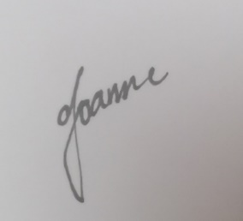

I accept this WBA.

(Joanne Ang Soo Yin)

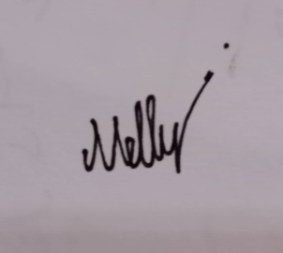

I accept this WBA.

(Nelly Tay Yee Ting)

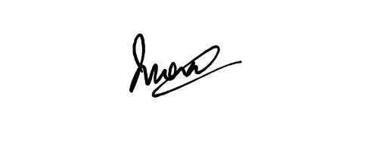

I accept this WBA

(Jonathan Wong Leong Shan)